

MANUFACTURER OF TPE&TPR

SOLUTIONS IN SOFT TOUCH MATERIALS

FACT SHEET

GP200 Series - TPE can be used to make toys and adult products

|  |  |
| --- | --- |
| Typical Applications   * Artificial skin * Water balloon | * Doll * Adult products |
|  |  |

|  |  |  |  |
| --- | --- | --- | --- |
| **Physical Property** | **Unit** | GP200-0701Q | GP200-3001 |
| Hardness | Shore | 7 OO | 30A |
| Density | g/cm3 | 0.84 | 0.87 |
| Tensile Strength | MPa | 2.5 | 3.6 |
| Elongation at Break | % | 1200 | 650 |

 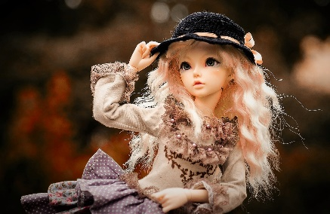

Our Know-how – Your Advantage

With super soft, dry and comfortable, high transparency, fully recyclable features, GP200 can be used to make a variety of toys and adult products with realistic feelings.

具行业内符合最高质量标准。 无论是彩色的，高透明度的，抗撕裂的还是特

**Safety first:**

**Standards that meet market requirements:**

**Passed FDA177.2600 water-based test and GB4806.7 food-grade test;**

**Contains no latex, PVC, phthalates or heavy metals**

**Soft surface**

**Very good sensory properties and low migration levels**

**Durability:**

Excellent elasticity

Hardness ranges from Shore Q5 to Shore 30A

Technical Data

TALK TO OUR EXPERTS！

**SUNGLORY PLASTIC (VIET NAM) COMPANY LIMITED - SOUTHEAST ASIA**

 Candy @sungallon.com