FACT SHEET

GP310 Series - TPE for consumer goods, tool handles and automotive interior and exterior trim



MANUFACTURER OF TPE&TPR

SOLUTIONS IN SOFT TOUCH MATERIALS

|  |  |
| --- | --- |
| Typical Applications   * Tool handle * Steering wheel sheath | * Phone case * Handlebar |
|  |  |

|  |  |  |  |
| --- | --- | --- | --- |
| **Physical Property** | **Unit** | GP310-553A | GP310-8501 |
| Hardness | Shore | 55A | 85A |
| Density | g/cm3 | 1.05 | 1.21 |
| Tensile Strength | MPa | 4.5 | 36 |
| Elongation at Break | % | 650 | 660 |

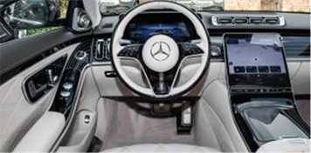

Our Know-how – Your Advantage

With high peel strength, high tear strength, good scratch resistance, good colorability, fully recyclable features, GP310 can be used to produce consumer goods, power tool handle, Automotive trim in various colors.

具行业内符合最高质量标准。 无论是彩色的，高透明度的，抗撕裂的还是特

**Safety first:**

**Standards that meet market requirements:**

**Comply with REACH, ROHS, polycyclic aromatic hydrocarbons, nonylphenol and other environmental requirements**

**Excellent coating properties for PC, ABS, ABS/PC, PA, AS, ASA, PMMA, PCTG and PETG**

**Soft, dry and beautiful surface with first class touch and low VOC**

**Can meet the requirements of UL94 V-0 flame retardant specification**

**Durability:**

**Excellent mechanical properties, such as high peel strength and tear strength, scratch resistance**

**Ultraviolet resistance**

**Wear-resistant**

**Hardness ranges from Shore 40A to Shore 90A**

Technical Data

TALK TO OUR EXPERTS！

**SUNGLORY PLASTIC (VIET NAM) COMPANY LIMITED - SOUTHEAST ASIA**

 Candy@sungallon.com