FACT SHEET

GP320 Series - TPE for making tool handles



MANUFACTURER OF TPE&TPR

SOLUTIONS IN SOFT TOUCH MATERIALS

|  |  |
| --- | --- |
| Typical Applications   * Handle |  |
|  |  |

|  |  |  |  |
| --- | --- | --- | --- |
| **Physical Property** | **Unit** | GP320-4501 | GP320-7501 |
| Hardness | Shore | 45A | 75A |
| Density | g/cm3 | 1.08 | 1.10 |
| Tensile Strength | MPa | 2.5 | 3.5 |
| Elongation at Break | % | 450 | 400 |

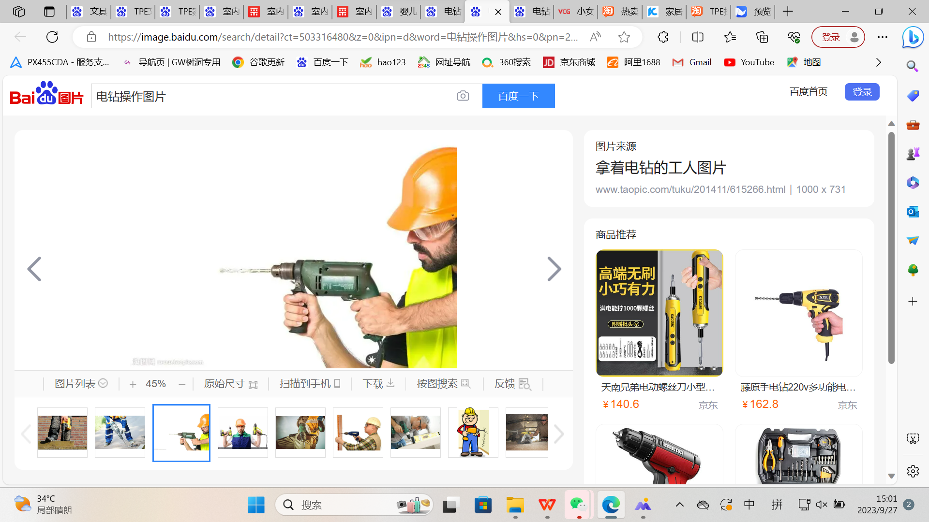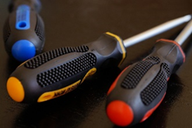

Our Know-how – Your Advantage

With matte, anti-skid, good colorability, easy to process, fully recyclable features, GP320 can be used to make a variety of safe tool handles.

具行业内符合最高质量标准。 无论是彩色的，高透明度的，还是特

**Safety first:**

**Standards that meet market requirements:**

**Products are environmentally friendly, comply with REACH, ROHS, polycyclic aromatic hydrocarbons, nonylphenol and other environmental requirements, products can be recycled**

**Fog surface, non-slip**

**Durability:**

**Excellent surface quality and feel**

**Hardness ranges from Shore 40A to Shore 90A**

Technical Data

TALK TO OUR EXPERTS！

**SUNGLORY PLASTIC (VIET NAM) COMPANY LIMITED - SOUTHEAST ASIA**

 Candy@sungallon.com