FACT SHEET

GP420 Series - TPE for dolls and shoes



MANUFACTURER OF TPE&TPR

SOLUTIONS IN SOFT TOUCH MATERIALS

|  |  |
| --- | --- |
| Typical Applications   * Shoes * Dolls |  |
|  |  |
|  |  |

|  |  |  |  |
| --- | --- | --- | --- |
| **Physical Property** | **Unit** | GP420-4003 | GP420-9003 |
| Hardness | Shore | 40A | 90A |
| Density | g/cm3 | 1.08 | 1.10 |
| Tensile Strength | MPa | 3.5 | 6.3 |
| Elongation at Break | % | 450 | 300 |

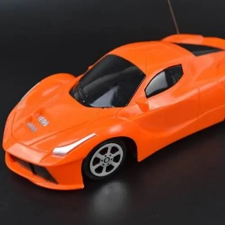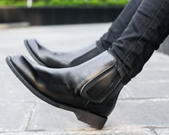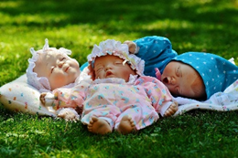

Our Know-how – Your Advantage

With resistant to high tension, resistant to high torque, high elasticity, easy coloring and oil spraying, fully recyclable features, GP420 can be used for safe dolls and shoes.

具行业内符合最高质量标准。 无论是彩色的，高透明度的，抗撕裂的还是特

**Safety first:**

**Standards that meet market requirements:**

**Passed FDA177.2600 water-based test and GB4806.7 food-grade test;**

**Contains no latex, PVC, phthalates or heavy metals**

**Very good sensory properties and low migration levels**

**Fully recyclable**

**Durability:**

Excellent mechanical properties, such as good resistance to high torque and tensile strength, high elasticity;

Hardness ranges from Shore A 10 to Shore A 95

Technical Data

TALK TO OUR EXPERTS！

**SUNGLORY PLASTIC (VIET NAM) COMPANY LIMITED - SOUTHEAST ASIA**

 Candy@sungallon.com