FACT SHEET

GP520 Series – Universal series TPE



MANUFACTURER OF TPE&TPR

SOLUTIONS IN SOFT TOUCH MATERIALS

|  |  |
| --- | --- |
| Typical Applications   * Casters * Toothbrushes * Buttons | * Toy tires * Foot mat * Ice grids |
|  |  |

|  |  |  |  |
| --- | --- | --- | --- |
| **Physical Property** | **Unit** | GP520-5003 | GP520-9005 |
| Hardness | Shore | 50A | 90A |
| Density | g/cm3 | 1.05 | 1.2 |
| Tensile Strength | MPa | 4.8 | 6.0 |
| Elongation at Break | % | 800 | 480 |

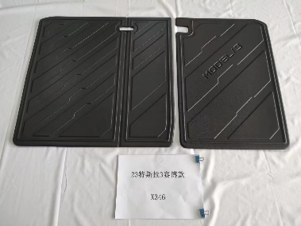

Our Know-how – Your Advantage

With resistant to high tension, high elasticity, easy to process, fully recyclable features, GP520 can be used for all kinds of safe buttons, casters, foot mat, toothbrushes, tires, ice grids, etc.

具行业内符合最高质量标准。 无论是彩色的，高透明度的，抗撕裂的还是特

**Safety first:**

**Standards that meet market requirements:**

**Passed FDA177.2600 water-based test and GB4806.7 food-grade test;**

**Contains no latex, PVC, phthalates or heavy metals**

**Very good sensory properties and low migration levels**

**Durability:**

Excellent mechanical properties, such as good tensile strength and high elasticity

Hardness ranges from Shore A 10 to Shore A 90

Technical Data

TALK TO OUR EXPERTS！

**SUNGLORY PLASTIC (VIET NAM) COMPANY LIMITED - SOUTHEAST ASIA**

 Candy@sungallon.com