FACT SHEET

GP540 Series - TPE for cable jacketing



MANUFACTURER OF TPE&TPR

SOLUTIONS IN SOFT TOUCH MATERIALS

|  |  |
| --- | --- |
| Typical Applications   * Cable jacketing |  |
|  |  |
|  |  |

|  |  |  |  |
| --- | --- | --- | --- |
| **Physical Property** | **Unit** | GP540-7503(N)F | GP540-9003(N)F |
| Hardness | Shore | 75A | 90A |
| Density | g/cm3 | 1.09 | 1.09 |
| Tensile Strength | MPa | 4.5 | 6.0 |
| Elongation at Break | % | 400 | 250 |

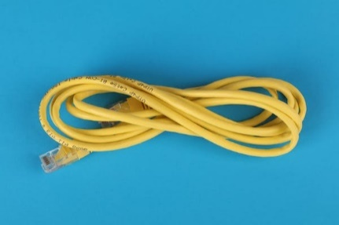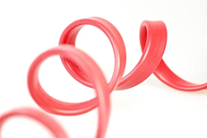

Our Know-how – Your Advantage

With soft feel and comfortable, high elasticity, UV resistant, precipitation resistant, halogen-free features, GP540 can be used for a variety of cable jacketing.

具行业内符合最高质量标准。 无论是彩色的，高透明度的，抗撕裂的还是特

**Safety first:**

**Standards that meet market requirements:**

**Halogen - free**

**Soft and comfortable surface**

**Very good sensory properties and low migration levels**

**Durability:**

Excellent weather resistance, precipitation resistance, high elasticity

Hardness ranges from Shore A 55 to Shore A 95

Technical Data

TALK TO OUR EXPERTS！

**SUNGLORY PLASTIC (VIET NAM) COMPANY LIMITED - SOUTHEAST ASIA**

 Candy@sungallon.com