FACT SHEET

GP620 Series - TPE for consumer goods, tool handles and automotive interior and exterior trim



MANUFACTURER OF TPE&TPR

SOLUTIONS IN SOFT TOUCH MATERIALS

|  |  |
| --- | --- |
| Typical Applications   * Handle * Steel wheel sheath | * Phone case * Gear sleeve |
|  |  |

|  |  |  |  |
| --- | --- | --- | --- |
| **Physical Property** | **Unit** | GP620-5001 | GP620-3601D |
| Hardness | Shore | 50A | 36D |
| Density | g/cm3 | 1.02 | 1.21 |
| Tensile Strength | MPa | 3 | 15.8 |
| Elongation at Break | % | 585 | 785 |

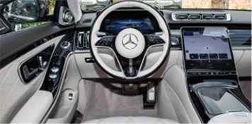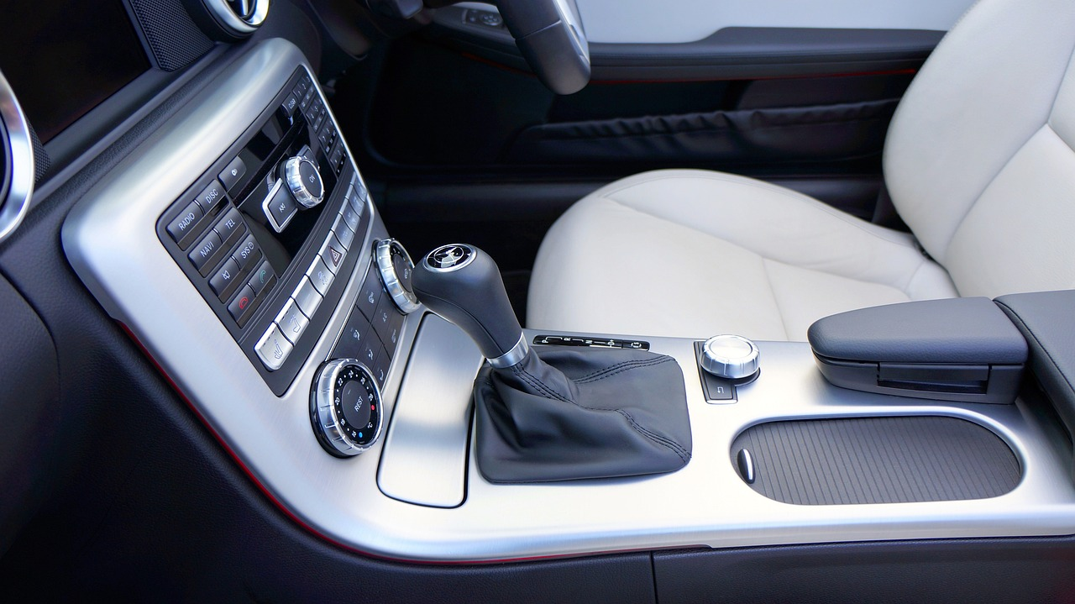

Our Know-how – Your Advantage

With soft touch, creep resistance, high resilience, high modulus, scratch resistance, hydrolysis resistance, aging resistance, corrosion resistance, recyclable features, GP620 can be used to produce safe consumer goods, power tool handle, automotive trim.

具行业内符合最高质量标准。 无论是彩色的，高透明度的，抗撕裂的还是特

**Safety first:**

**Standards that meet market requirements:**

**Comply with REACH, ROHS, polycyclic aromatic hydrocarbons, nonylphenol and other environmental requirements**

**Excellent coating properties for PC, ABS, ABS/PC, PBT**

**Soft, dry and elastic surface with excellent touch and low VOC**

**Durability:**

**Excellent mechanical properties, such as creep resistance, high modulus**

**Ultraviolet resistance**

**scratch-resistant**

**Hydrolysis resistance**

**Corrosion resistance**

**Hardness ranges from Shore 50A to Shore 36D**

Technical Data

TALK TO OUR EXPERTS！

**SUNGLORY PLASTIC (VIET NAM) COMPANY LIMITED - SOUTHEAST ASIA**

 Candy@sungallon.com