FACT SHEET

GP920 Series - TPE for home appliances, packaging and food containers



MANUFACTURER OF TPE&TPR

SOLUTIONS IN SOFT TOUCH MATERIALS

|  |  |
| --- | --- |
| Typical Applications   * Home appliances * Packaging | * Food containers |
|  |  |

|  |  |  |  |
| --- | --- | --- | --- |
| **Physical Property** | **Unit** | GP920-2504 | GP920-70DWPC |
| Hardness | Shore | 63D | 80D |
| Density | g/cm3 | 1.0 | 1.35 |
| Tensile Strength | MPa | 25 | 49 |
| Elongation at Break | % | 1300 | 3100 |

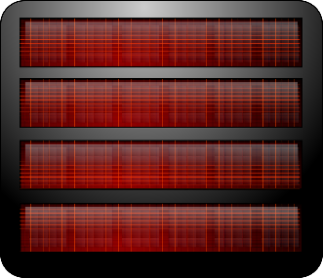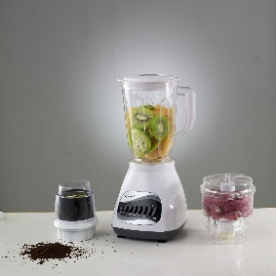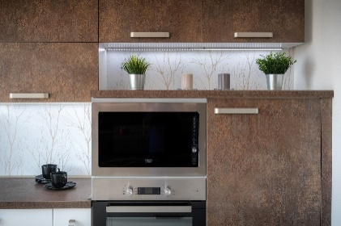

Our Know-how – Your Advantage

With high transparency, high temperature resistance, high gloss, high rigidity, high modulus, warp-resistant, low shrinkage features, GP920 can be used to produce a variety of safe home appliances, packaging and food containers.

具行业内符合最高质量标准。 无论是彩色的，高透明度的，抗撕裂的还是特

**Safety first:**

**Standards that meet market requirements:**

**Passed FDA177.2600 water-based test and GB4806.7 food-grade test;**

**Contains no latex, PVC, phthalates or heavy metals**

**Very good sensory properties and low migration levels**

**Durability:**

Excellent mechanical properties such as high rigidity, resistance to warping, high modulus and low shrinkage

High temperature resistance

Hardness ranges from Shore D 63 to Shore D 80

Technical Data

TALK TO OUR EXPERTS！

**SUNGLORY PLASTIC (VIET NAM) COMPANY LIMITED - SOUTHEAST ASIA**

 Candy@sungallon.com