FACT SHEET

GP100 Series - TPE for Toys and Sports Equipment



MANUFACTURER OF TPE&TPR

SOLUTIONS IN SOFT TOUCH MATERIALS

|  |  |
| --- | --- |
| Typical Applications   * Hand-muscle developer * Finger massage ball | * Chest expander * Toys |
|  |  |
|  |  |

|  |  |  |  |
| --- | --- | --- | --- |
| **Physical Property** | **Unit** | GP100-0501 | GP100-7001D |
| Hardness | Shore | 5A | 70D |
| Density | g/cm3 | 0.9 | 0.98 |
| Tensile Strength | MPa | 2 | 14 |
| Elongation at Break | % | 1200 | 500 |

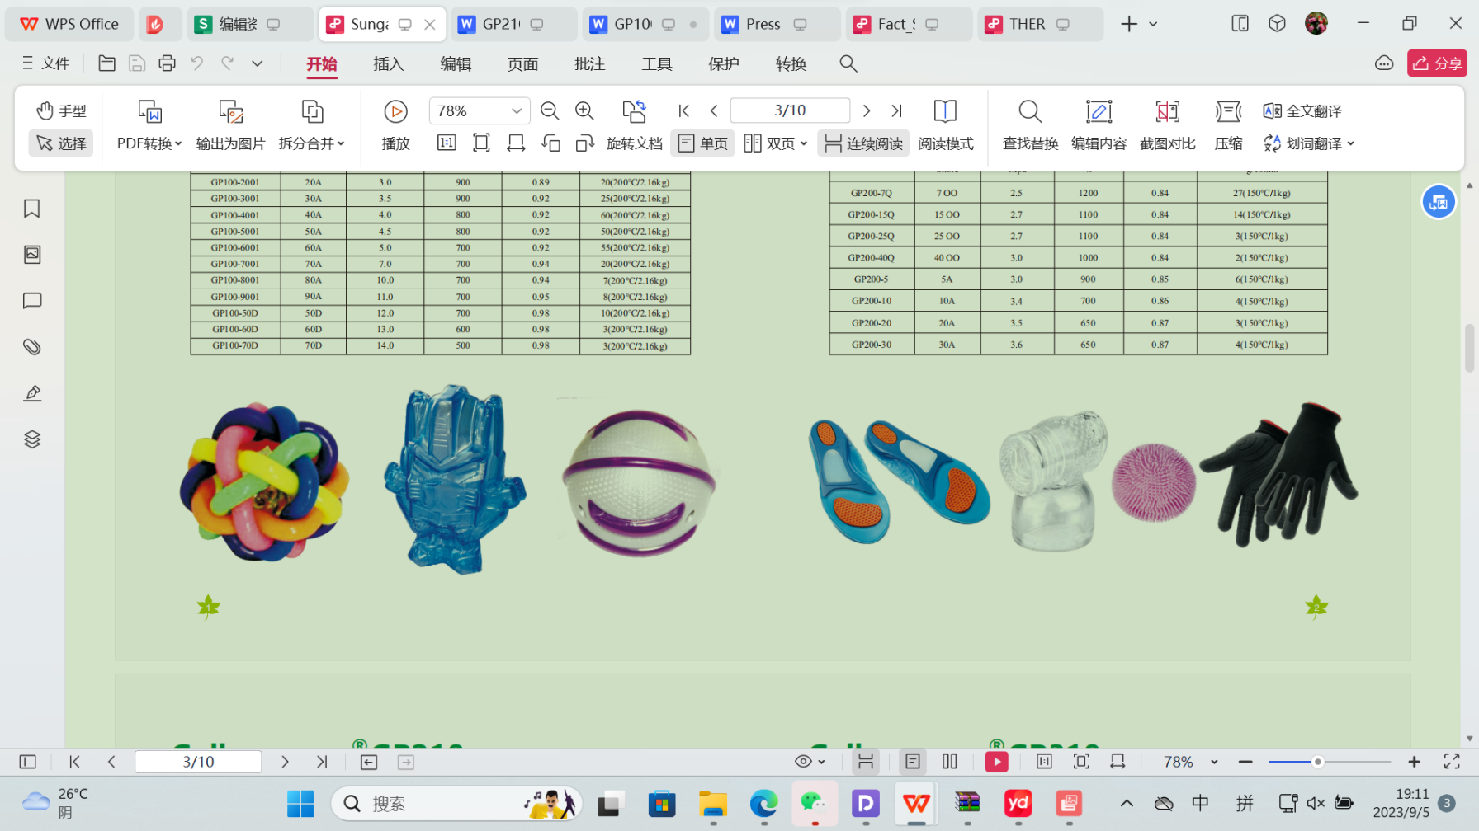

Our Know-how – Your Advantage

With high tension, high torque, high elasticity, easy coloring and paintable, fully recyclable features, GP100 can be used for safe toys and sports equipment in various colors.

业内符合最高质量标准。 无论是彩色的，高透明度的，抗撕裂的还是特

**Safety first:**

**Standards that meet market requirements:**

**Passed FDA177.2600 water-based test and GB4806.7 food-grade test;**

**Contains no latex, PVC, phthalates or heavy metals**

**Soft surface**

**Very good sensory properties and low migration levels**

**Durability:**

**Excellent mechanical properties, such as good tear resistance and tensile strength**

**Hardness ranges from Shore A 5 to Shore D 70**

Technical Data

TALK TO OUR EXPERTS！

**SUNGLORY PLASTIC (VIET NAM) COMPANY LIMITED - SOUTHEAST ASIA**

 Candy@sungallon.com