FACT SHEET

GP210 Series - TPE can make consumer goods and toys



MANUFACTURER OF TPE&TPR

SOLUTIONS IN SOFT TOUCH MATERIALS

|  |  |
| --- | --- |
| Typical Applications   * Cosmetic brush * Seal ring * Rod handle | * Sports teeth braces * Handrail |
|  |  |

|  |  |  |  |
| --- | --- | --- | --- |
| **Physical Property** | **Unit** | GP210-2004 | GP210-8004 |
| Hardness | Shore | 20A | 80A |
| Density | g/cm3 | 0.88 | 0.89 |
| Tensile Strength | MPa | 4 | 10 |
| Elongation at Break | % | 750 | 700 |

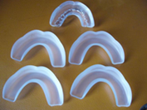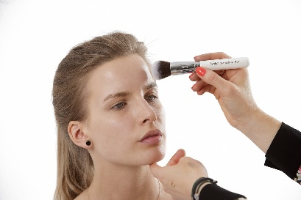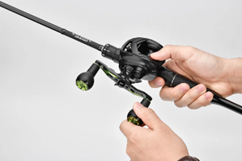

Our Know-how – Your Advantage

With high wear resistance, good temperature resistance, good weather resistance, good feel, good colorability, food contact level, safe and environmentally friendly features, GP210 can be used to make a variety of safe consumer goods and toys.

具行业内符合最高质量标准。 无论是彩色的，高透明度的，抗撕裂的还是特

**Safety first:**

**Standards that meet market requirements:**

**Passed FDA177.2600 water-based test and GB4806.7 food-grade test;**

**Contains no latex, PVC, phthalates or heavy metals**

**Soft surface**

**Very good sensory properties and low migration levels**

**Durability:**

Excellent mechanical properties, such as good wear resistance

Hardness ranges from Shore 20A to Shore 60D

Technical Data

TALK TO OUR EXPERTS！

**SUNGLORY PLASTIC (VIET NAM) COMPANY LIMITED - SOUTHEAST ASIA**

 Candy@sungallon.com