FACT SHEET

GP410 Series - TPE for toy figures and foamed shoe materials



MANUFACTURER OF TPE&TPR

SOLUTIONS IN SOFT TOUCH MATERIALS

|  |  |
| --- | --- |
| Typical Applications   * Toy figures * Vent toy | * Stress relief ball * Foamed shoe materials |
|  |  |

|  |  |  |  |
| --- | --- | --- | --- |
| **Physical Property** | **Unit** | GP410-35 | GP410-9202 |
| Hardness | Shore | 35A | 92A |
| Density | g/cm3 | 0.94 | 0.98 |
| Tensile Strength | MPa | 3.5 | 12.1 |
| Elongation at Break | % | 700 | 450 |

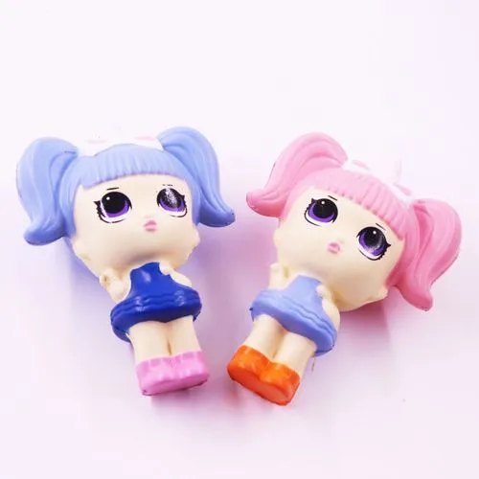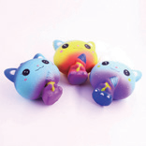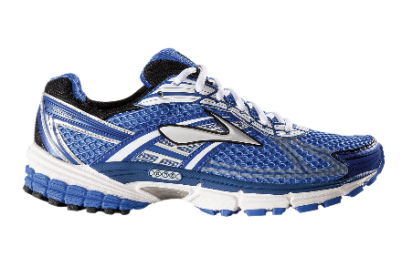

Our Know-how – Your Advantage

With high tension, high torque, high elasticity, easy coloring and paintable, fully recyclable features, GP410 can be used for safe toy figures and foamed shoe materials.

具行业内符合最高质量标准。 无论是彩色的，高透明度的，抗撕裂的还是特

**Safety first:**

**Standards that meet market requirements:**

**Food grade contact requirements;**

**Contains no latex, PVC, phthalates or heavy metals**

**Durability:**

Excellent mechanical properties, such as good tear resistance and tensile strength, high elasticity

Hardness ranges from Shore A 10 to Shore A 95

Technical Data

TALK TO OUR EXPERTS！

**SUNGLORY PLASTIC (VIET NAM) COMPANY LIMITED - SOUTHEAST ASIA**

 Candy@sungallon.com