FACT SHEET

GP510 Series – TPE for toy tire leather, handle, sheet gasket



MANUFACTURER OF TPE&TPR

SOLUTIONS IN SOFT TOUCH MATERIALS

|  |  |
| --- | --- |
| Typical Applications   * Toy tire leather * Sheet gasket | * Handle |
|  |  |

|  |  |  |  |
| --- | --- | --- | --- |
| **Physical Property** | **Unit** | GP100-50A | GP100-70A |
| Hardness | Shore | 50A | 70A |
| Density | g/cm3 | 1.06 | 1.15 |
| Tensile Strength | MPa | 4 | 3.2 |
| Elongation at Break | % | 600 | 500 |

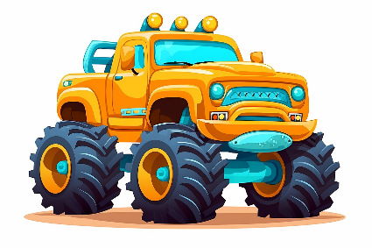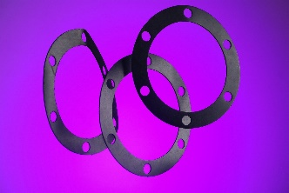

Our Know-how – Your Advantage

With resistant to high tension, high elasticity, easy to process, fully recyclable features, GP510 can be used for safe toy tire leather, handle, sheet gasket.

具行业内符合最高质量标准。 无论是彩色的，高透明度的，抗撕裂的还是特

**Safety first:**

**Standards that meet market requirements:**

**Passed FDA177.2600 water-based test and GB4806.7 food-grade test;**

**Contains no latex, PVC, phthalates or heavy metals**

**Soft surface**

**Very good sensory properties and low migration levels**

**Durability:**

Excellent mechanical properties, such as good tensile strength and high elasticity

Hardness ranges from Shore A 10 to Shore A 95

Technical Data

TALK TO OUR EXPERTS！

**SUNGLORY PLASTIC (VIET NAM) COMPANY LIMITED - SOUTHEAST ASIA**

 Candy@sungallon.com