FACT SHEET

GP640 Series - TPE for electronic appliances



MANUFACTURER OF TPE&TPR

SOLUTIONS IN SOFT TOUCH MATERIALS

|  |  |
| --- | --- |
| Typical Applications   * Electrical and electronic connectors |  |
|  |  |

|  |  |  |  |
| --- | --- | --- | --- |
| **Physical Property** | **Unit** | GP640-60A | GP640-95A |
| Hardness | Shore | 60A | 95A |
| Density | g/cm3 | 1.1 | 1.1 |
| Tensile Strength | MPa | 4.5 | 8.8 |
| Elongation at Break | % | 450 | 350 |

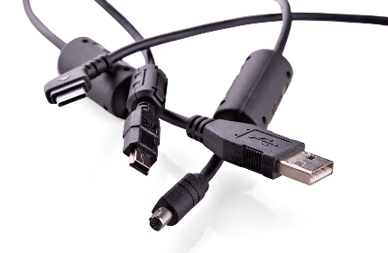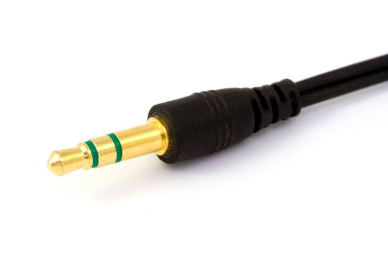

Our Know-how – Your Advantage

With dry touch, excellent elasticity, good UV stability, halogen-free, fully recyclable, comply with UL94-V0 requirements features, GP640 can be used to produce safe connectors for various electronic appliances.

具行业内符合最高质量标准。 无论是彩色的，高透明度的，抗撕裂的还是特

**Safety first:**

**Standards that meet market requirements:**

**Contains no latex, PVC, phthalates or heavy metals**

**Feel dry**

**Halogen-free**

**UL94-V0**

**Durability:**

High resilience, resistant to yellowing

Hardness ranges from Shore A 60 to Shore A 95

Technical Data

TALK TO OUR EXPERTS！

**SUNGLORY PLASTIC (VIET NAM) COMPANY LIMITED - SOUTHEAST ASIA**

 Candy@sungallon.com